**Tema 2 de laborator**

7a) Cate exemplare au statusul eronat?  
  
SELECT COUNT(status)

FROM (SELECT status, CASE

WHEN ((t.title_id, c.copy_id) NOT IN (SELECT title_id, copy_id

FROM rental

WHERE act_ret_date IS NULL))

THEN 'AVAILABLE'

ELSE 'RENTED'

END AS "Exemplare neeronate"

FROM title t

JOIN title_copy c ON t.title_id = c.title_id)

WHERE status != "Exemplare neeronate";

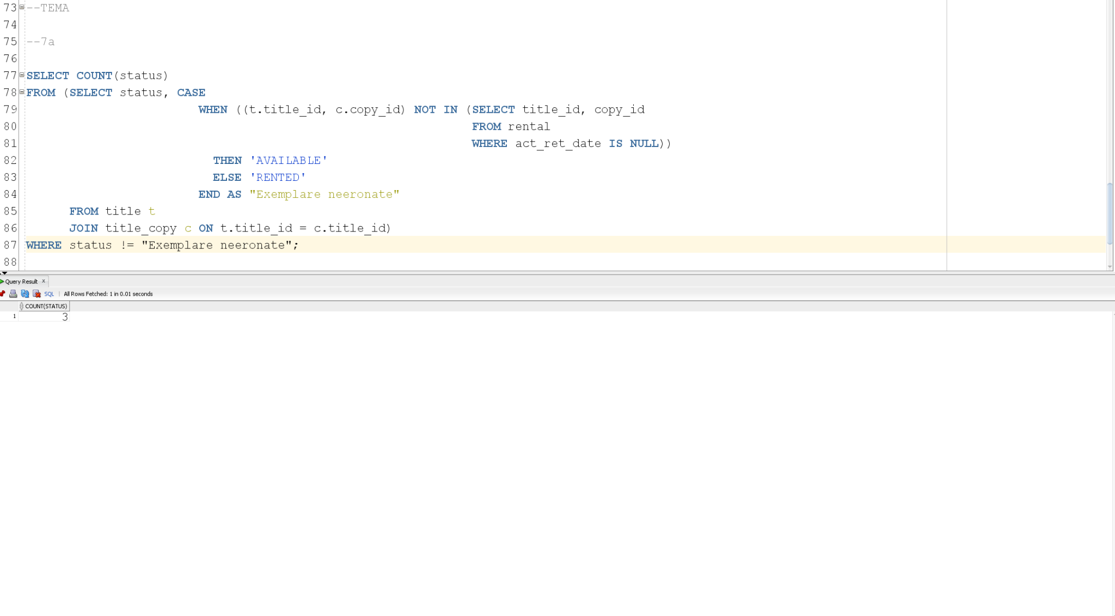

7b) Setati statusul corect pentru toate exemplarele care au statusul eronat. Salvati actualizarile realizate.

CREATE TABLE title_copy_IDO AS SELECT * FROM title_copy;

SELECT *

FROM title_copy_IDO;

SELECT *

FROM title_copy;

UPDATE title_copy_IDO SET status = CASE

WHEN (title_id, copy_id) NOT IN (SELECT title_id, copy_id

FROM rental

WHERE act_ret_date IS NULL)

THEN 'AVAILABLE'

ELSE 'RENTED'

END;

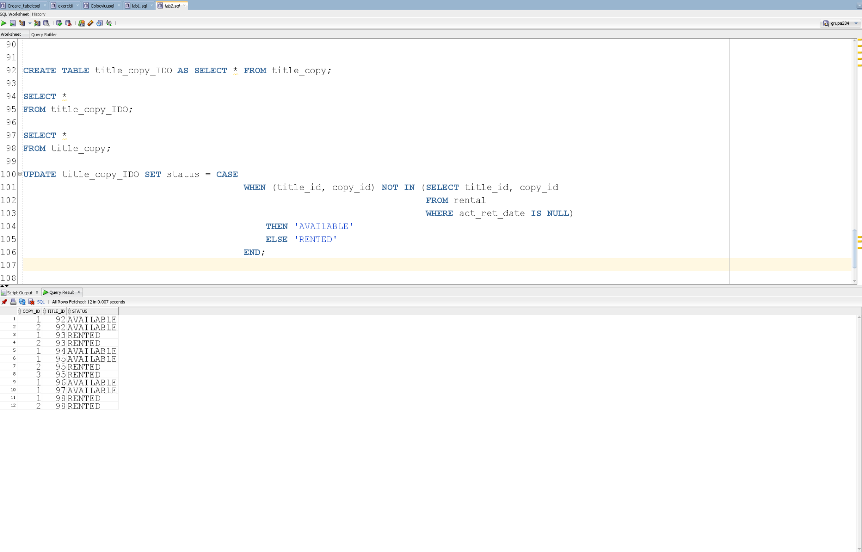

8) Toate filmele rezervate au fost imprumutate la data rezervarii? Afisati “DA” sau “NU” in functie de situatie.

SELECT (CASE

WHEN(SELECT COUNT(*)

FROM rental ren, reservation res

WHERE ren.title_id = res.title_id

AND ren.member_id = res.member_id

AND book_date != res_date) <= 0

THEN 'DA'

ELSE 'NU'

END) AS "Imprumutate la aceeasi data?"

FROM dual;

